This is how to run the family map server.

To run this:
1. Extract all the contents to a folder on your machine.

NEXT DO ONE OF THE FOLLOWING:

2ai. Open a terminal, and go to the folder where the extracted contents reside.
2aii. Run in the terminal "java -jar FamilyMapServer_v*-*.jar ####" (Where * is the rest of the file name of the jar file and #### is any port number you choose (usually 8080 or something similar)). EG: java -jar FamilyMapServer_4-4.jar 8080
2aiii. In your favorite Internet browser go to localhost:#### (remember #### is the port you used when starting the server in 2aii.) and you should see the server's landing page.

OR YOU COULD DO THIS

2bi. Open eclipse
2bii. Click file → New → Java Project
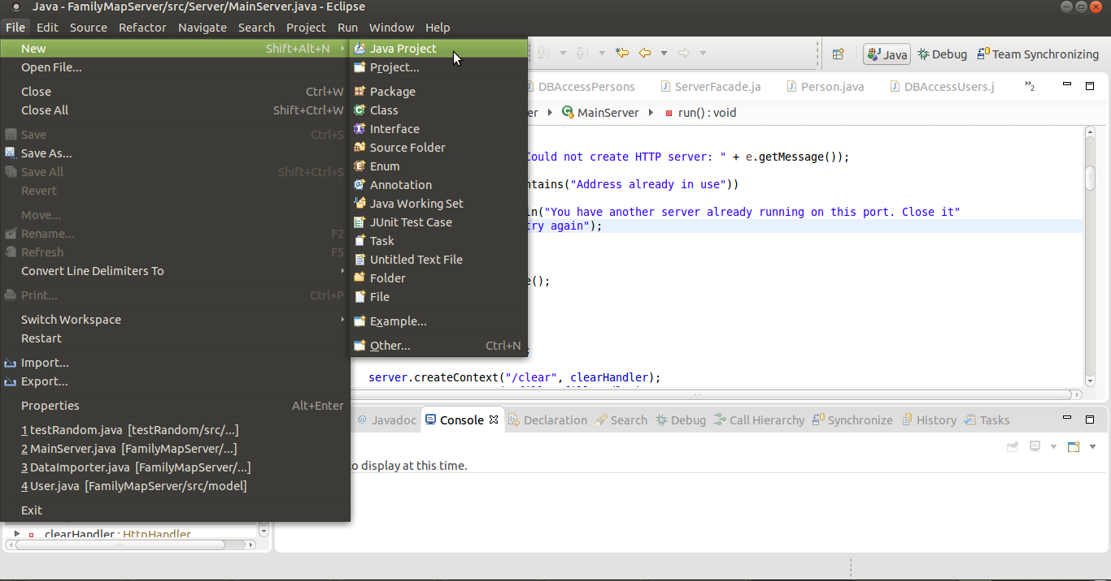

2biii. De select “Use default location”
2biv Click browse. Go to the folder where you extracted everything.

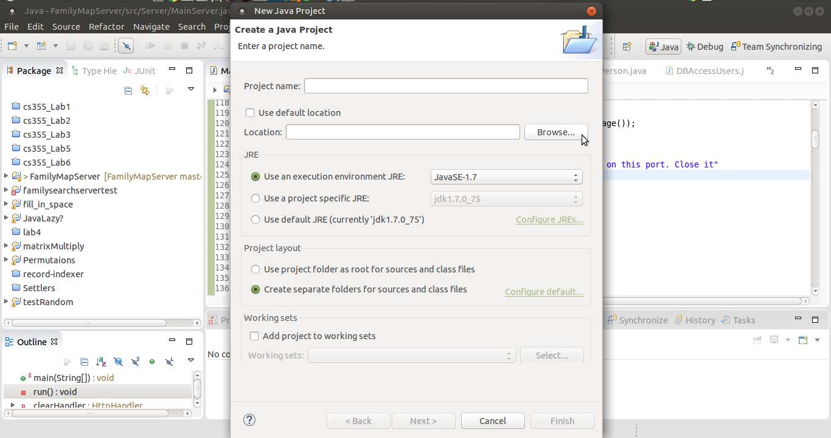
2bv. Click Finish.
2bvi. The server should now be a project in your workspace. Open the project, open the src folder, and open the Server package.
2bvii. Right click “Main Server.java” then “Run as” then “Java application”.
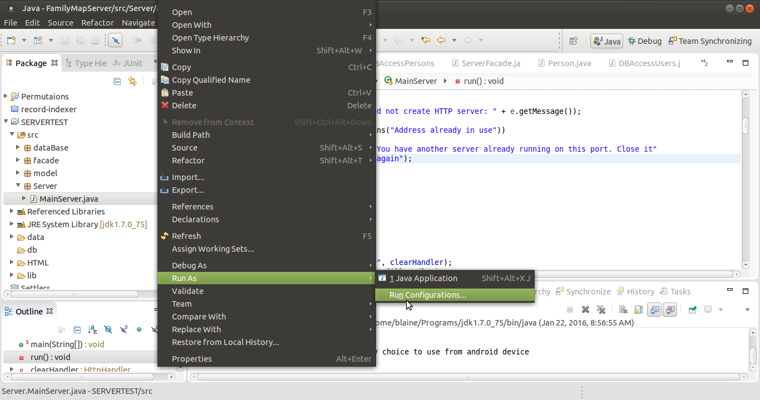
2bviii. It is very likely an error will occur because there are no program arguments. Again right click “Main Server.java” then “Run as” then “Run configurations”.
2bxi. Select the “Arguments” tab. In the program arguments enter a port number (eg: 8080).
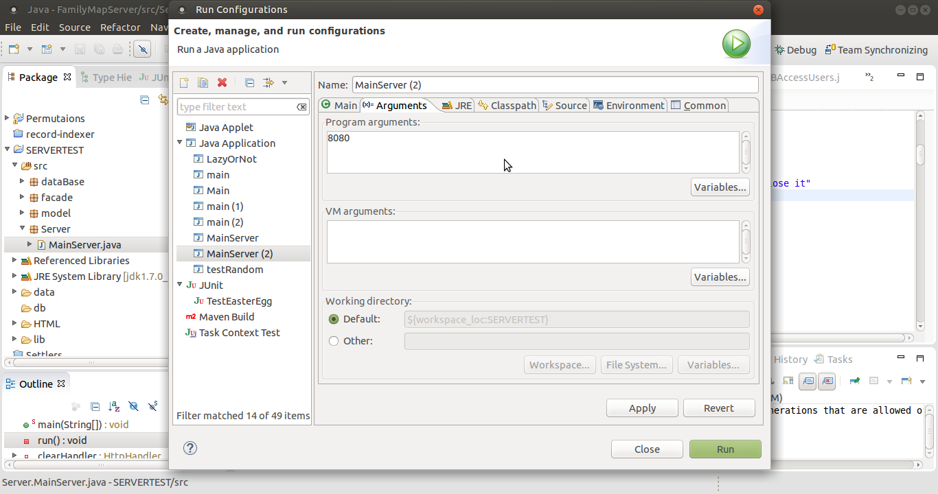
2bx. Click run. The server should now be running on port you entered.
2bxi. In your favorite Internet browser navigate to localhost:#### and you should see the server's landing page.
